**New Timesheet Interface**

**Associate login**

Use the below Path or link to access Timesheet interface and login using your network credentials (LAN ID/ Password)

Path: Easy > Timesheet Entry

Link: <https://timesheet.techmahindra.com/>

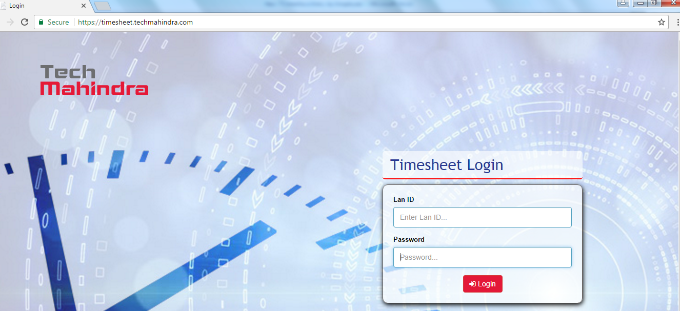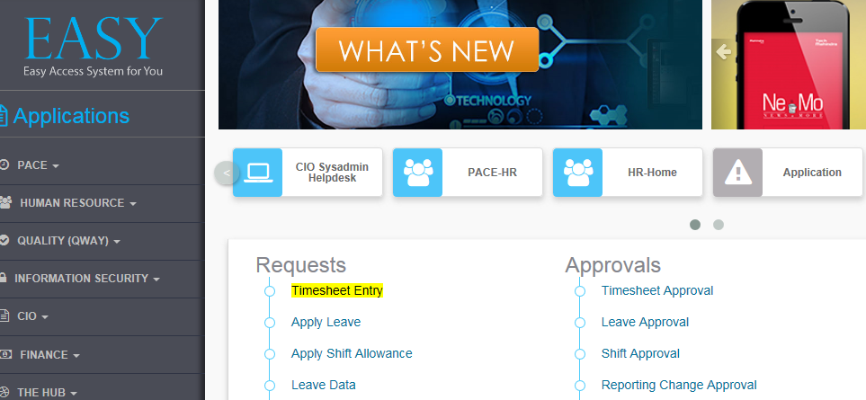

You will be navigated to below screen with current week details. Associate can chose previous dates by using “Select Month” and “Select week” for previous dates

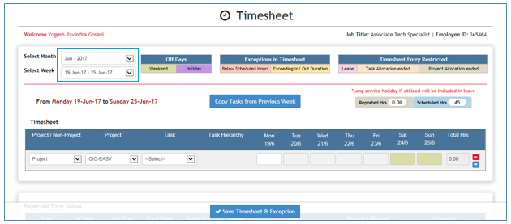

Associate need to select category from drop down values in “Project / Non-Project”, if category is project then need to select appropriate project and task. If Category is Non Project, select the appropriate task.

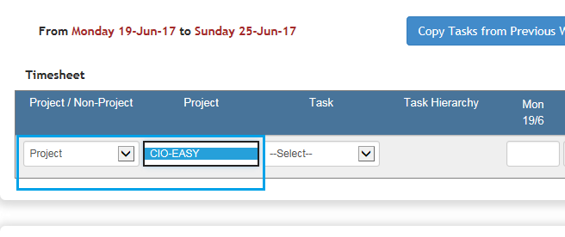

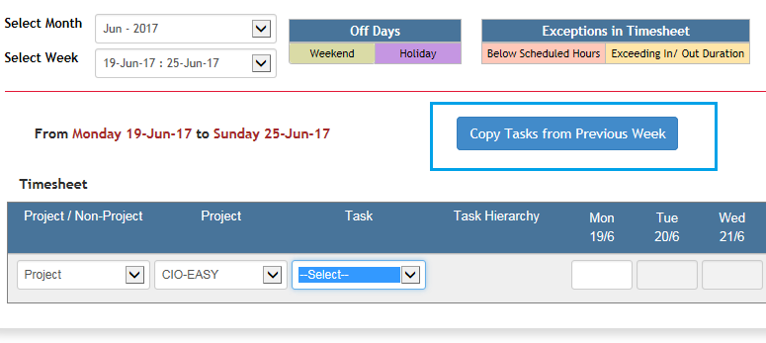Associate can copy the tasks from previous week (if there is no change in tasks) by clicking on “Copy Tasks from Previous Week”.

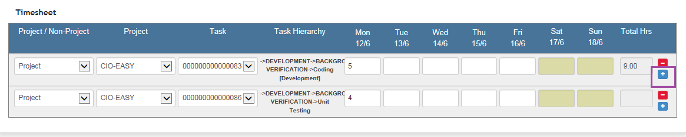Associate need to click on “+” button to add more rows, this is applicable for Associate who are working on multiple projects or assigned to multiple tasks of same project.

Associate can even enter his timesheet efforts based on the actual efforts spent on project. He can enter timesheet efforts can be logged in Project category and also Non project category by adding a new row.

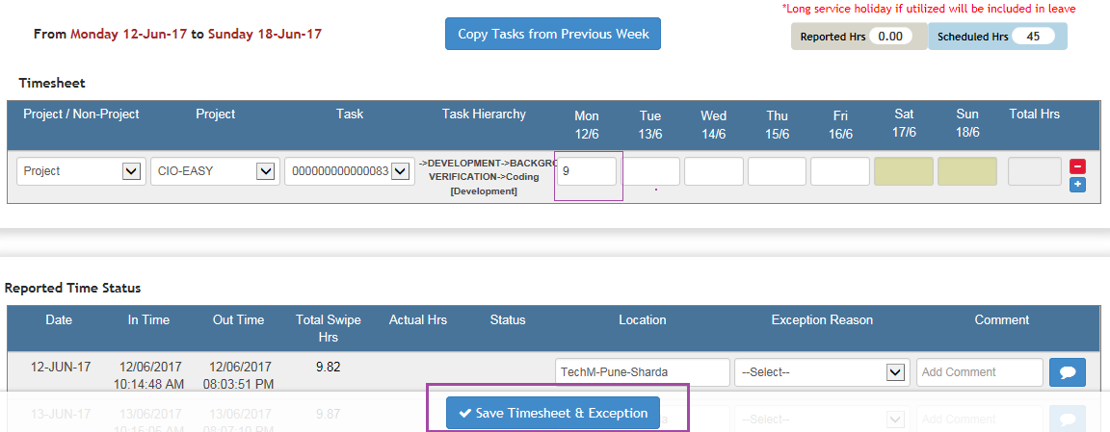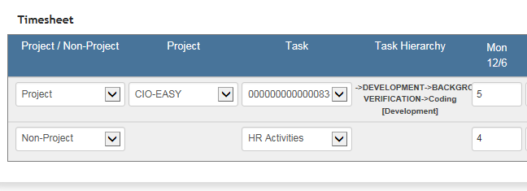

Associate need to click on “*Save Timesheet & Exception*” button to save the data post filling timesheet.

Once clicked on “*Save Timesheet & Exception*” data will be saved and confirmation of the same will be displayed as per below screen.

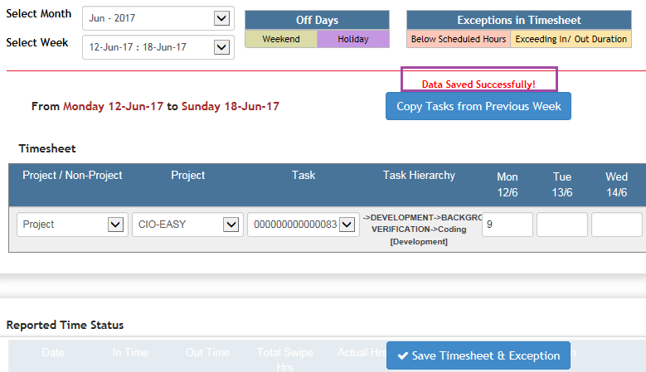

**---- End of Document ---**